Dog and Cat background scenery moodboard

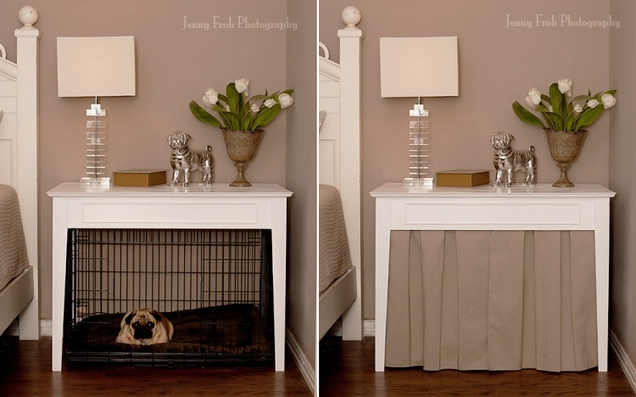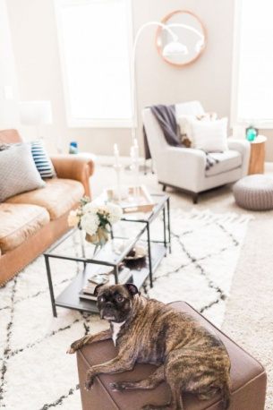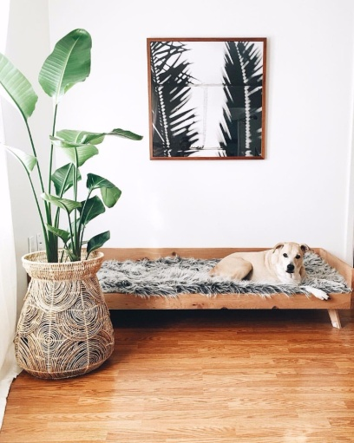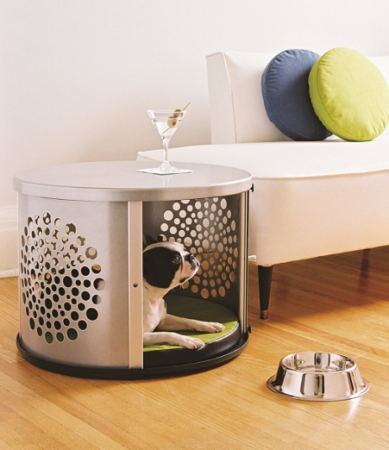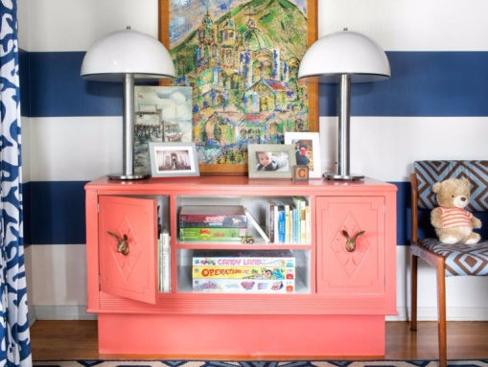

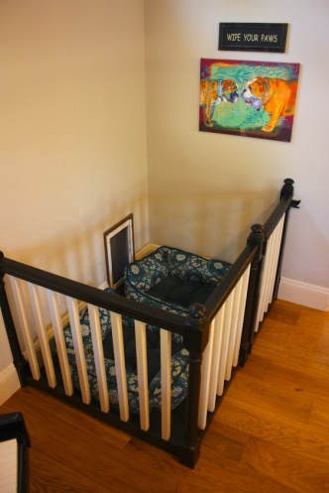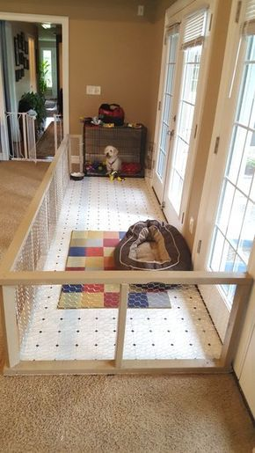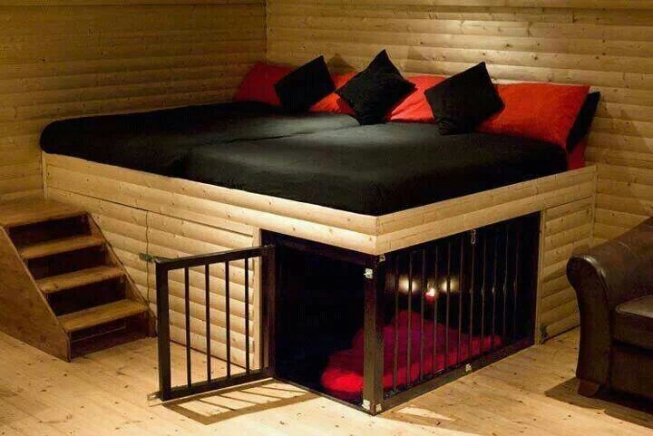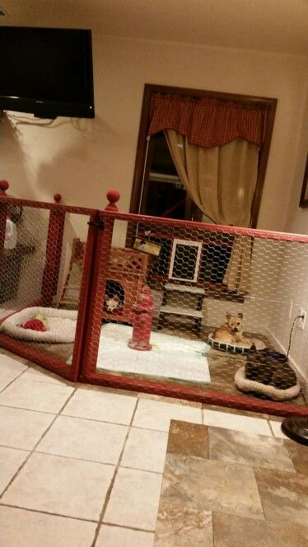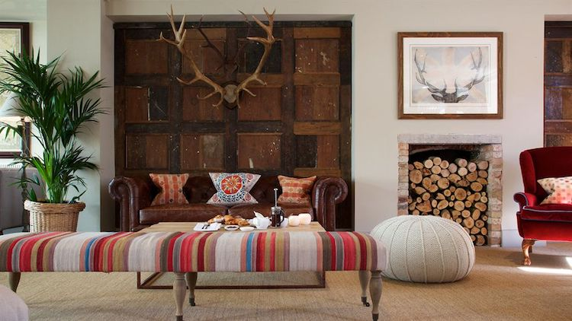

References

FARIA, B. (2017). *Kid-Friendly, Pet-Friendly Living Room Combines Style and Function*. [online] Livingroomideas.eu. Available at: <http://livingroomideas.eu/kid-friendly-pet-friendly-living-room-combines-style-function/> [Accessed 21 Nov. 2017].

Gergaud, R. (2017). *Blog / News - Top 10 dog friendly budget boutique hotels | Doris & Dicky*. [online] Dorisanddicky.com. Available at: <https://www.dorisanddicky.com/blog-news/item/1288-top-10-dog-friendly-budget-boutique-hotels> [Accessed 21 Nov. 2017].

Kirkland, M. (2017). *Best 25+ Dog House Outside Ideas On Pinterest | Inside Dog Houses ... - Nationals Home Plate*. [online] Nationalshomeplate.com. Available at: <http://nationalshomeplate.com/detail/27739496-best-25-dog-house-outside-ideas-on-pinterest-inside-dog-houses.html> [Accessed 21 Nov. 2017].

Kirkland, M. (2017). *Best 25+ Inside Dog Houses Ideas On Pinterest | Dog Food Bowls ... - Nationals Home Plate*. [online] Nationalshomeplate.com. Available at: <http://nationalshomeplate.com/detail/00f2ccde-best-25-inside-dog-houses-ideas-on-pinterest-dog-food-bowls.html> [Accessed 21 Nov. 2017].

LOLA, L. (2016). *Dog Crate Table*. [online] Jenny Froh Photography. Available at: <http://jennyfroh.com/2013/05/dog-crate-table/> [Accessed 21 Nov. 2017].

Pinterest. (2017). *Favorites for Dog Lovers!*. [online] Available at: <https://www.pinterest.co.uk/pin/384565255661110483/> [Accessed 21 Nov. 2017].

Sipfon.org. (2017). *Great Snack Table With Rounded Shape Design Combined Perforated Decoration Also Base Dog Storage And White Couch Unify Yellows Blue Circle Throw Pillows Featuring Laminate Timber Flooring Ideas. Furniture. Sophisticated Snack Table Under Sofas Designs. slide Under Couch Table. sofa Side Table. side Sofa. wooden Snack Tables. Furniture | Sipfon Home Deco*. [online] Available at: <http://sipfon.org/sophisticated-snack-table-under-sofas-designs/great-snack-table-with-rounded-shape-design-combined-perforated-decoration-also-base-dog-storage-and-white-couch-unify-yellows-blue-circle-throw-pillows-featuring-laminate-timber-flooring-ideas/> [Accessed 21 Nov. 2017].

Steward, R. (2017). *50+ Best Puppy Room Ideas*. [online] meowlogy. Available at: <https://meowlogy.com/2017/05/06/50-best-puppy-room-ideas/> [Accessed 21 Nov. 2017].

The Everygirl. (2016). *10 Commandments to Designing Your Living Room - The Everygirl*. [online] Available at: <http://theeverygirl.com/10-commandments-to-designing-your-living-room/> [Accessed 21 Nov. 2017].